Piecewise Vehicle Performance Modeling
from Onboard Diagnostic Measurements
Jiale Jiang, Emily Robinson, Hector Rodruguez, and Yaoyi Peng
Mt. San Antonio College
September 27, 2026

Abstract—We developed piecewise vehicle models from three Volkswagen Jetta and three Toyota Camry OBD records. Lines fitted to Kalman-estimated acceleration produce quadratic velocity and cubic position, while separate RPM and fuel-rate fits represent acceleration and braking. Compared with mean acceleration, the linear fits reduce acceleration residuals but improve velocity reconstruction only for Camry launch. The results describe similar driving inputs; cruise operation and travel beyond the recorded speed range require additional assumptions. The quarter-mile scenario predicts 26.5 s for the Jetta and 26.2 s for the Camry; these extrapolations remain unvalidated.

I. Introduction
The purpose is to predict travel time, distance, engine RPM, and fuel use for courses that were not measured directly [1]. We use low-order equations because the records contain speed and engine information but no consistent throttle, brake, or gear input. These are empirical driving-scenario models, not a feedback controller or a test of maximum vehicle performance.

II. Measurements and Processing
The recorded procedure was to park on relatively flat pavement, start logging before launch, accelerate toward 35 mph, and decelerate toward rest. Three logs were retained for each vehicle. The project used OBD Fusion; the Jetta is identified as a 2022 SE in the source code. The Camry year and powertrain are not confirmed. A repeated test should use the same route, driver, vehicle load, and approximate pedal input, with logging operated while stationary or by a passenger.
TABLE I
RECORDED TRIAL COVERAGE
Trial | Rows | Span (s) | Rows/s | Peak mph
J1 | 156 | 18.84 | 8.23 | 34.80
J2 | 130 | 16.40 | 7.86 | 36.66
J3 | 141 | 16.56 | 8.46 | 37.28
C1 | 481 | 24.01 | 19.99 | 35.42
C2 | 510 | 25.45 | 20.00 | 34.18
C3 | 457 | 22.80 | 20.00 | 34.80
J = Jetta; C = Camry. Row rate = (N − 1)/elapsed time; this does not establish the refresh rate of each signal.
Jetta logs contain time, speed, RPM, app acceleration, trip distance, trip fuel, and instantaneous/total MPG. Camry logs contain time, speed, RPM, and fuel mass rate [2]. We convert mph to ft/s by multiplying by 5280/3600, and lb/min to lb/s by dividing by 60. Camry distance and fuel are cumulative trapezoidal integrals. Jetta plots use changes in logged trip distance and fuel. Camry fuel stays in lb of mass, not gallons. Figs. 1–2 show all three records for each vehicle.
Jetta trial 3 has a repeated final timestamp, which remains in the raw records. Camry speed is often held across adjacent rows, and all three records end near 1.86 mph rather than at a measured stop. For model fitting, launch begins at the last zero before peak speed; braking runs from the last peak to the first subsequent zero or the record end. These selections exclude long stationary periods from the moving fits.
Differentiating quantized speed amplifies noise. The Kalman filter estimates speed and acceleration together, predicting their next values and correcting them with observed speed [3]. We fit its smoother acceleration estimates, accepting some lag. These acceleration samples are estimated, not independent measurements; recorded speed is retained for checking the integrated motion model.

III. Piecewise Models
Let τ be time since a phase begins, v₀ its initial speed, and x₀ its starting position. A first-order polyfit estimates initial acceleration a₀ (ft/s²) and jerk j (ft/s³) from the pooled Kalman acceleration samples [4]. Integrating gives:
a = a₀ + jτ (1)
v = v₀ + a₀τ + ½jτ² (2)
x = x₀ + v₀τ + ½a₀τ² + (j/6)τ³ (3)
The baseline is the mean of the same pooled acceleration samples, with j = 0. Each full moving phase is fitted directly; polyval evaluates its line [5]. We integrate both models from each trial’s recorded initial velocity and compare with recorded speed. Table II reports velocity reconstruction error on these same trials, not independent-course accuracy.
RMSE = √[mean((vmodel − vrecorded)²)] (4)
TABLE II
MOTION COEFFICIENTS AND VELOCITY RECONSTRUCTION RMSE
Phase | a₀ | j | Const. a | Linear a
J accel | 2.370 | 1.348 | 14.95 | 17.56
J brake | -5.916 | -0.070 | 10.39 | 10.59
C accel | 5.355 | -0.182 | 9.02 | 7.13
C brake | -4.023 | -0.140 | 6.31 | 7.34
a₀ in ft/s²; j in ft/s³; the last two columns are velocity RMSE in ft/s. Figs. 3–4 show Kalman acceleration samples and their fits.
Launch acceleration RMSE decreases from 5.35 to 4.81 ft/s² for Jetta and 1.93 to 1.83 ft/s² for Camry; braking changes are small. However, velocity RMSE improves only for Camry launch and increases in the other three phases. The filter corrects velocity at each update, so integrating its fitted acceleration does not reproduce those corrections. Filter lag and differences between trials also limit reconstruction. Lower acceleration residuals therefore do not establish better speed prediction.
RPM is fitted against speed separately during acceleration and braking with polyfit and evaluated with polyval [4]. These curves describe phase averages, not identified gears. Substituting modeled speed gives RPM versus time; stationary RPM uses a typical initial-idle value averaged across trials. Fuel rate is linear in speed except for Jetta braking, where a constant sample mean gives a coarse phase average and does not resolve transient spikes. Invalid speed/MPG ratios are excluded before fitting; negative fuel predictions are clipped to zero. The formulas are:
RPM = c₂v² + c₁v + c₀ (5)
qf = max(0, b₁v + b₀), F = ∫qf dt (6)
TABLE III
RPM AND FUEL COEFFICIENTS
Phase | [c₂, c₁, c₀] | [b₁, b₀]
J accel | -2.46, 169, 875 | 2.31e-05, 0.000685
J brake | 0.538, 10.4, 753 | 0, 0.000119
C accel | -0.383, 14.7, 2.25e+03 | -1.13e-05, 0.00455
C brake | 0.485, -9.83, 773 | -1.08e-05, 0.00066
Use v in ft/s. RPM is rpm. Fuel output is gal/s for Jetta and lb/s for Camry; coefficient units follow from these inputs/outputs.
Initial-idle estimates are 877 rpm and 9.74e-05 gal/s for Jetta; 1324 rpm and 0.00121 lb/s for Camry.
Jetta’s positive launch jerk represents rising fitted acceleration; Camry’s negative jerk represents tapering acceleration. These describe the pooled estimates, not a universal vehicle response. RPM and fuel coefficients describe empirical speed dependence, not gear ratios or engine torque. At idle, speed and acceleration are zero, position is constant, and fuel accumulates at an estimated idle rate. Jetta moving fuel rate is speed(mph)/(3600 × MPG) where MPG is positive; its idle rate comes from trip-fuel counter changes. Camry rate is recorded directly. Cruise fuel uses the midpoint of acceleration and braking rates at the target speed because steady-cruise data were not collected.

IV. Course Predictions
Course 1 reaches 15 mph and then cruises to 300 ft. Course 2 reaches 25 mph, cruises for the remaining distance, and brakes to rest at 600 ft. Course 3 covers 1320 ft at an average of 15 mph, so total time is 60 s; we choose a rest-to-rest acceleration/cruise/braking profile and solve for cruise speed. Course 4 accelerates throughout 1320 ft. Each course starts at launch, without an added idle period.
Neither rising nor falling linear acceleration is suitable for indefinite extrapolation. For Course 4, the model switches at the common launch duration to positive exponential decay. Acceleration, velocity, and position are continuous at the join:
a = ab exp(−u/T), u = t − tb (7)
v = vb + abT[1 − exp(−u/T)] (8)
x = xb + vbu + abT{u − T[1 − exp(−u/T)]} (9)
The join values are tb, xb, vb, and ab. For Camry, j < 0 and T = −ab/j matches the acceleration slope. For Jetta, j > 0; we assume T = tb, so jerk changes at the join. Neither tail is fitted to high-speed data. Above the highest recorded speed, RPM uses a constant RPM/speed ratio and fuel rate stays at its value at that speed. These assumptions limit confidence in quarter-mile predictions.
TABLE IV
JETTA COURSE PREDICTIONS
No. | Total s | Accel s | Brake s | Final mph | gal
1 | 16.13 | 4.22 | 0.00 | 15.00 | 0.0116
2 | 22.84 | 5.82 | 5.99 | 0.00 | 0.0158
3 | 60.00 | 4.44 | 3.94 | 0.00 | 0.0395
4 | 26.53 | 26.53 | 0.00 | 45.37 | 0.0454
Maximum acceleration for Courses 1–4: 8.06, 10.22, 8.36, 8.70 ft/s², respectively.
TABLE V
CAMRY COURSE PREDICTIONS
No. | Total s | Accel s | Brake s | Final mph | lb
1 | 15.80 | 4.44 | 0.00 | 15.00 | 0.0465
2 | 23.95 | 7.91 | 8.00 | 0.00 | 0.0556
3 | 60.00 | 4.89 | 5.45 | 0.00 | 0.1406
4 | 26.20 | 26.20 | 0.00 | 57.33 | 0.1071
Maximum acceleration for Courses 1–4: 5.35, 5.35, 5.35, 5.35 ft/s², respectively.
Figs. 5–6 show distance, velocity, acceleration, RPM, fuel rate, cumulative fuel, and fuel economy for all four courses. Camry economy is mi/lb; a justified fuel density is needed to report MPG.

V. Discussion and Conclusion
The low-order fits summarize estimated acceleration and give algebraically consistent position and velocity. The velocity comparison does not support calling linear acceleration uniformly better than the mean baseline. We use it here for conditional course scenarios, not validated predictions. Variable driving input, unknown gears, unmeasured cruising, and the Camry stopping tail limit confidence. Further tests should check steady cruise and repeated braking before increasing model complexity.
Volkswagen specifies 158 hp and 184 lb-ft for the 2022 Jetta 1.5 L engine [6]. Those ratings provide vehicle context, but these speed-only fits cannot independently recover engine torque or rated power. Nor can the fitted low-speed launches establish full-throttle quarter-mile performance. The next useful check is to predict a separate course before running it, then compare elapsed time and fuel with the recorded results.

References
[1] Mt. San Antonio College, Epic Quest 1d; Project 1 Overview v2; EpicQ1 grading rubric; and instructor virtual-course instructions. Course materials.
[2] Team records, JettaData.mat, CamryData.mat, DataParser.m, and SpeedKalmanFilter.m. Analysis dated September 27, 2026.
[3] MathWorks, “Linear Kalman Filters.” Online documentation
[4] MathWorks, “polyfit.” Online documentation
[5] MathWorks, “polyval.” Online documentation
[6] Volkswagen, “Updating the 2022 Jetta and Jetta GLI.” Online documentation
Electronic appendix: the original workspaces and DataParser.m retain all six trial tables. “Jetta recorded trials.png” and “Camry recorded trials.png” show complete traces; the fitting and course images below are also supplied separately at full resolution.

Jetta recorded trials
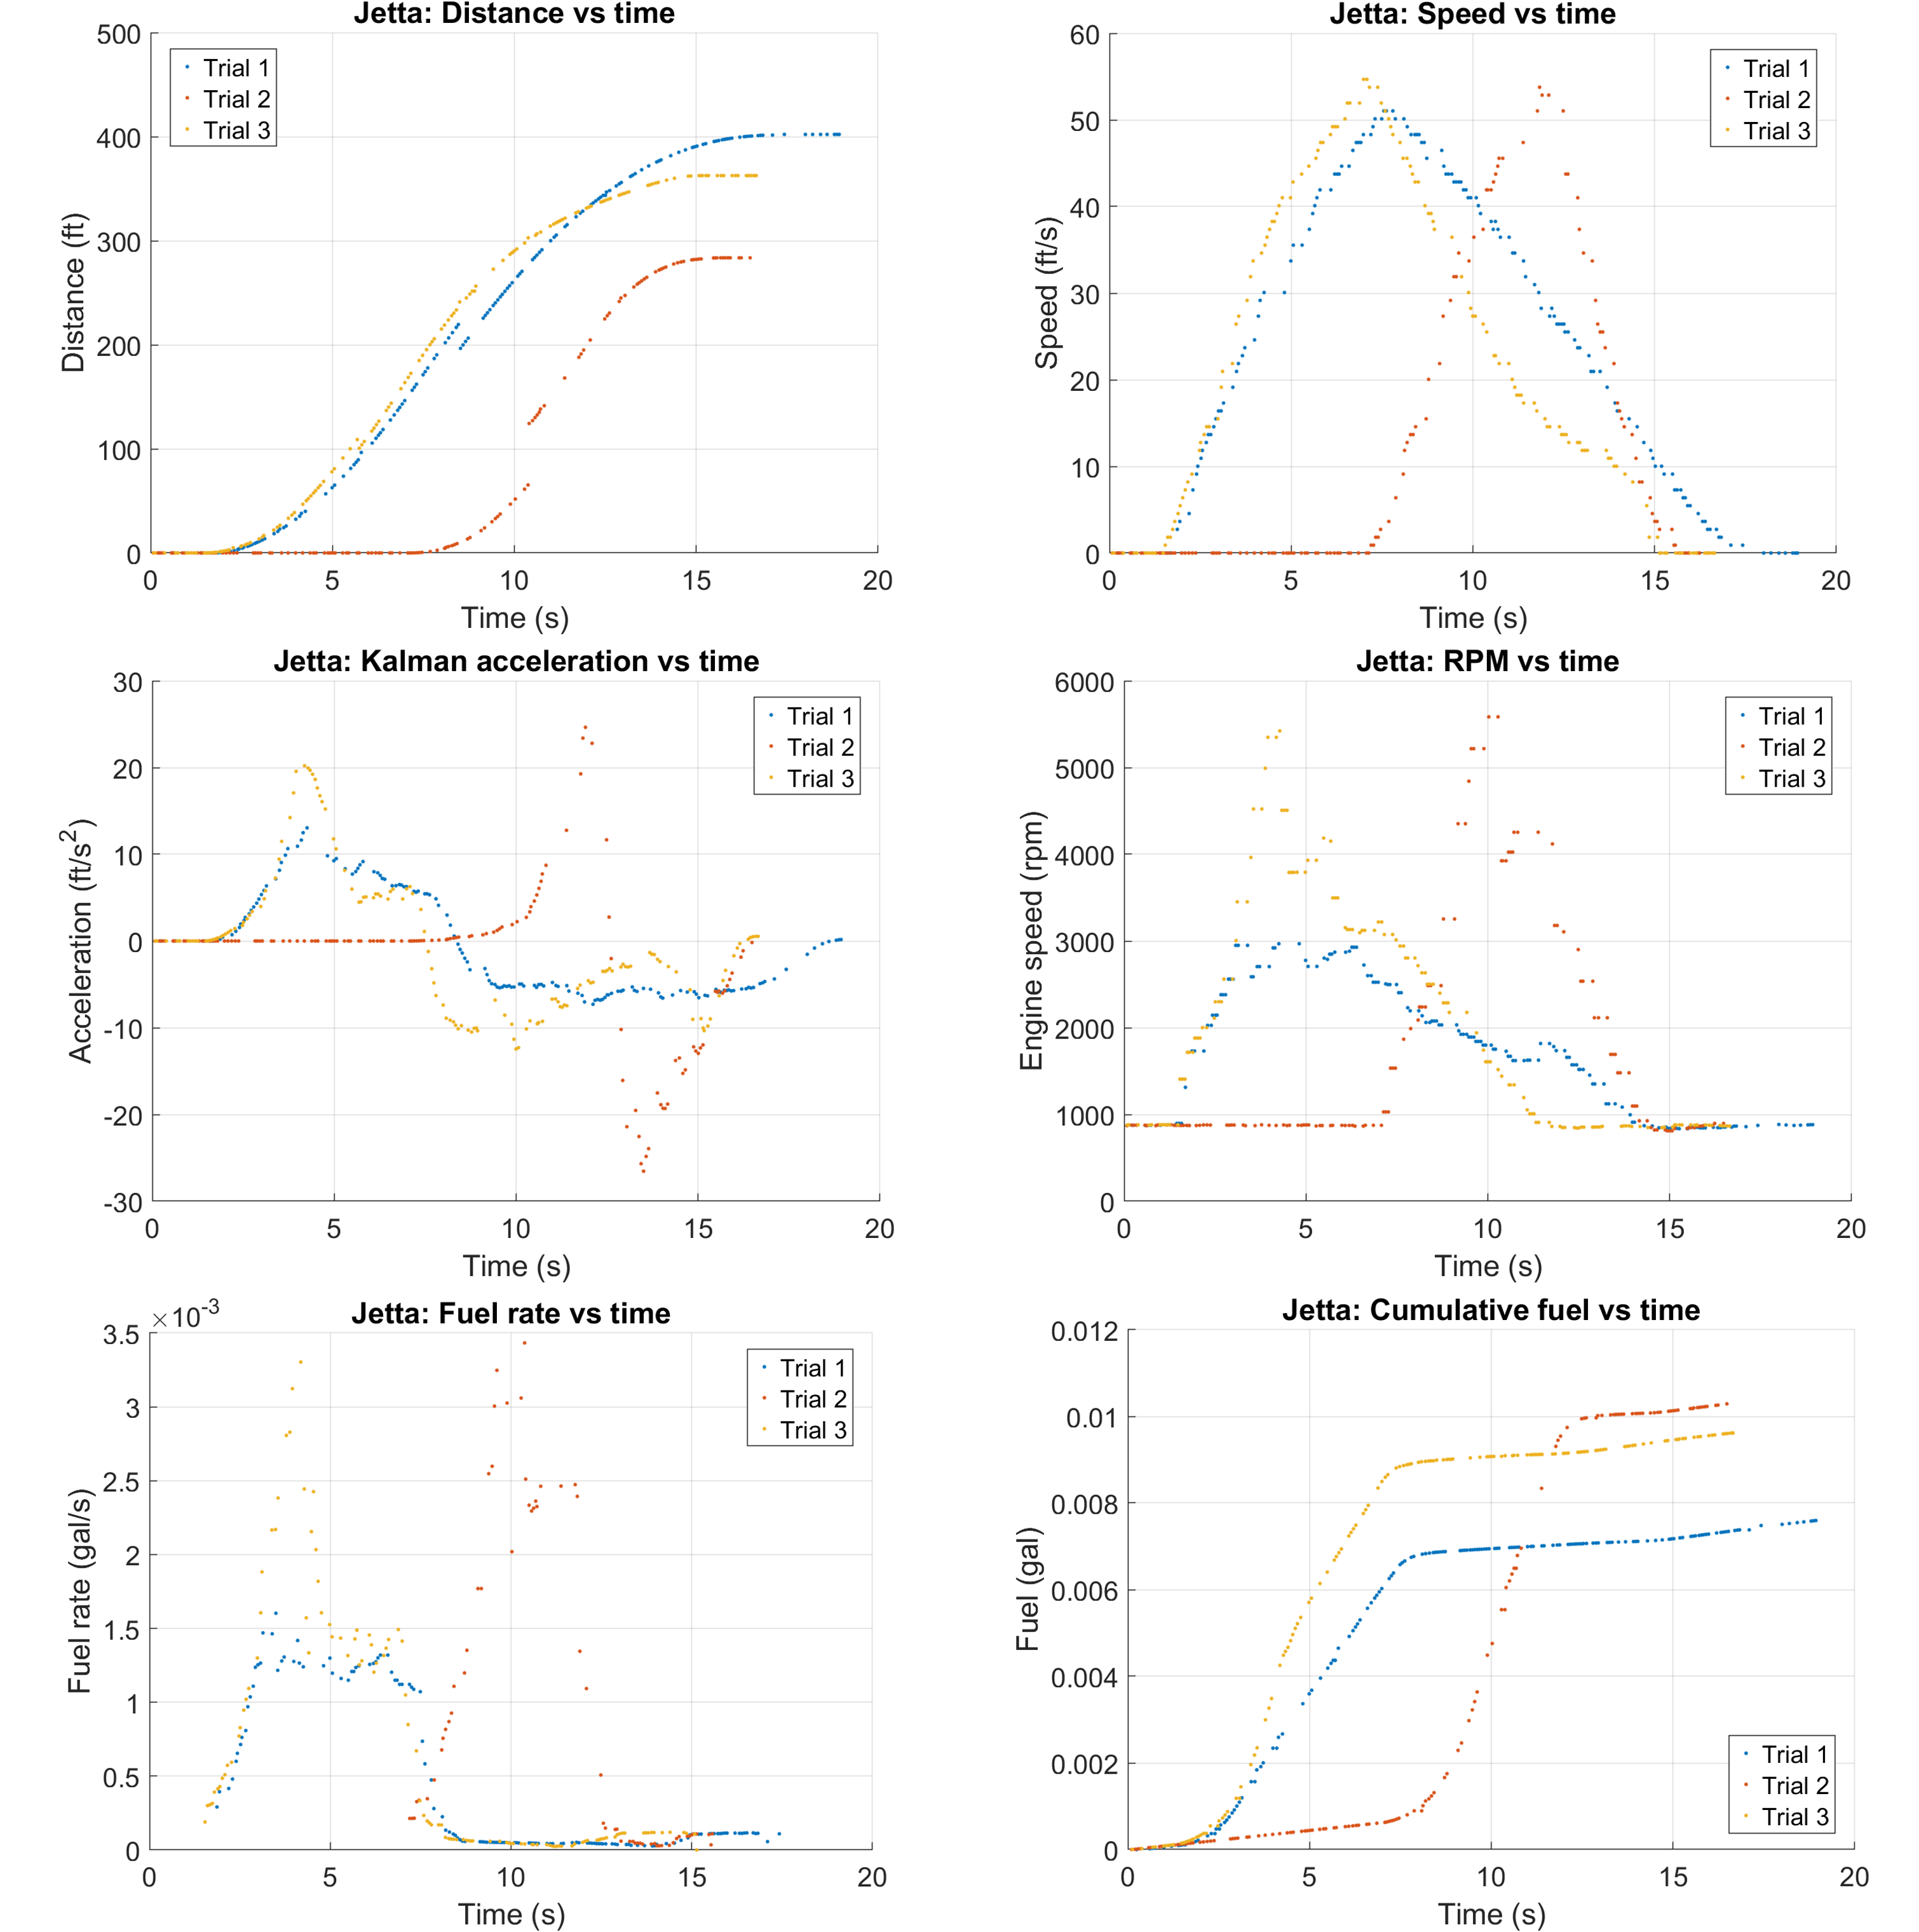
Fig. 1. Complete Jetta records plotted as discrete samples. Distance is the change in logged trip distance; acceleration is the Kalman estimate. Cumulative fuel is the increase after the first positive trip-fuel value. Missing idle speed/MPG ratios remain gaps in the fuel-rate plot.

Camry recorded trials
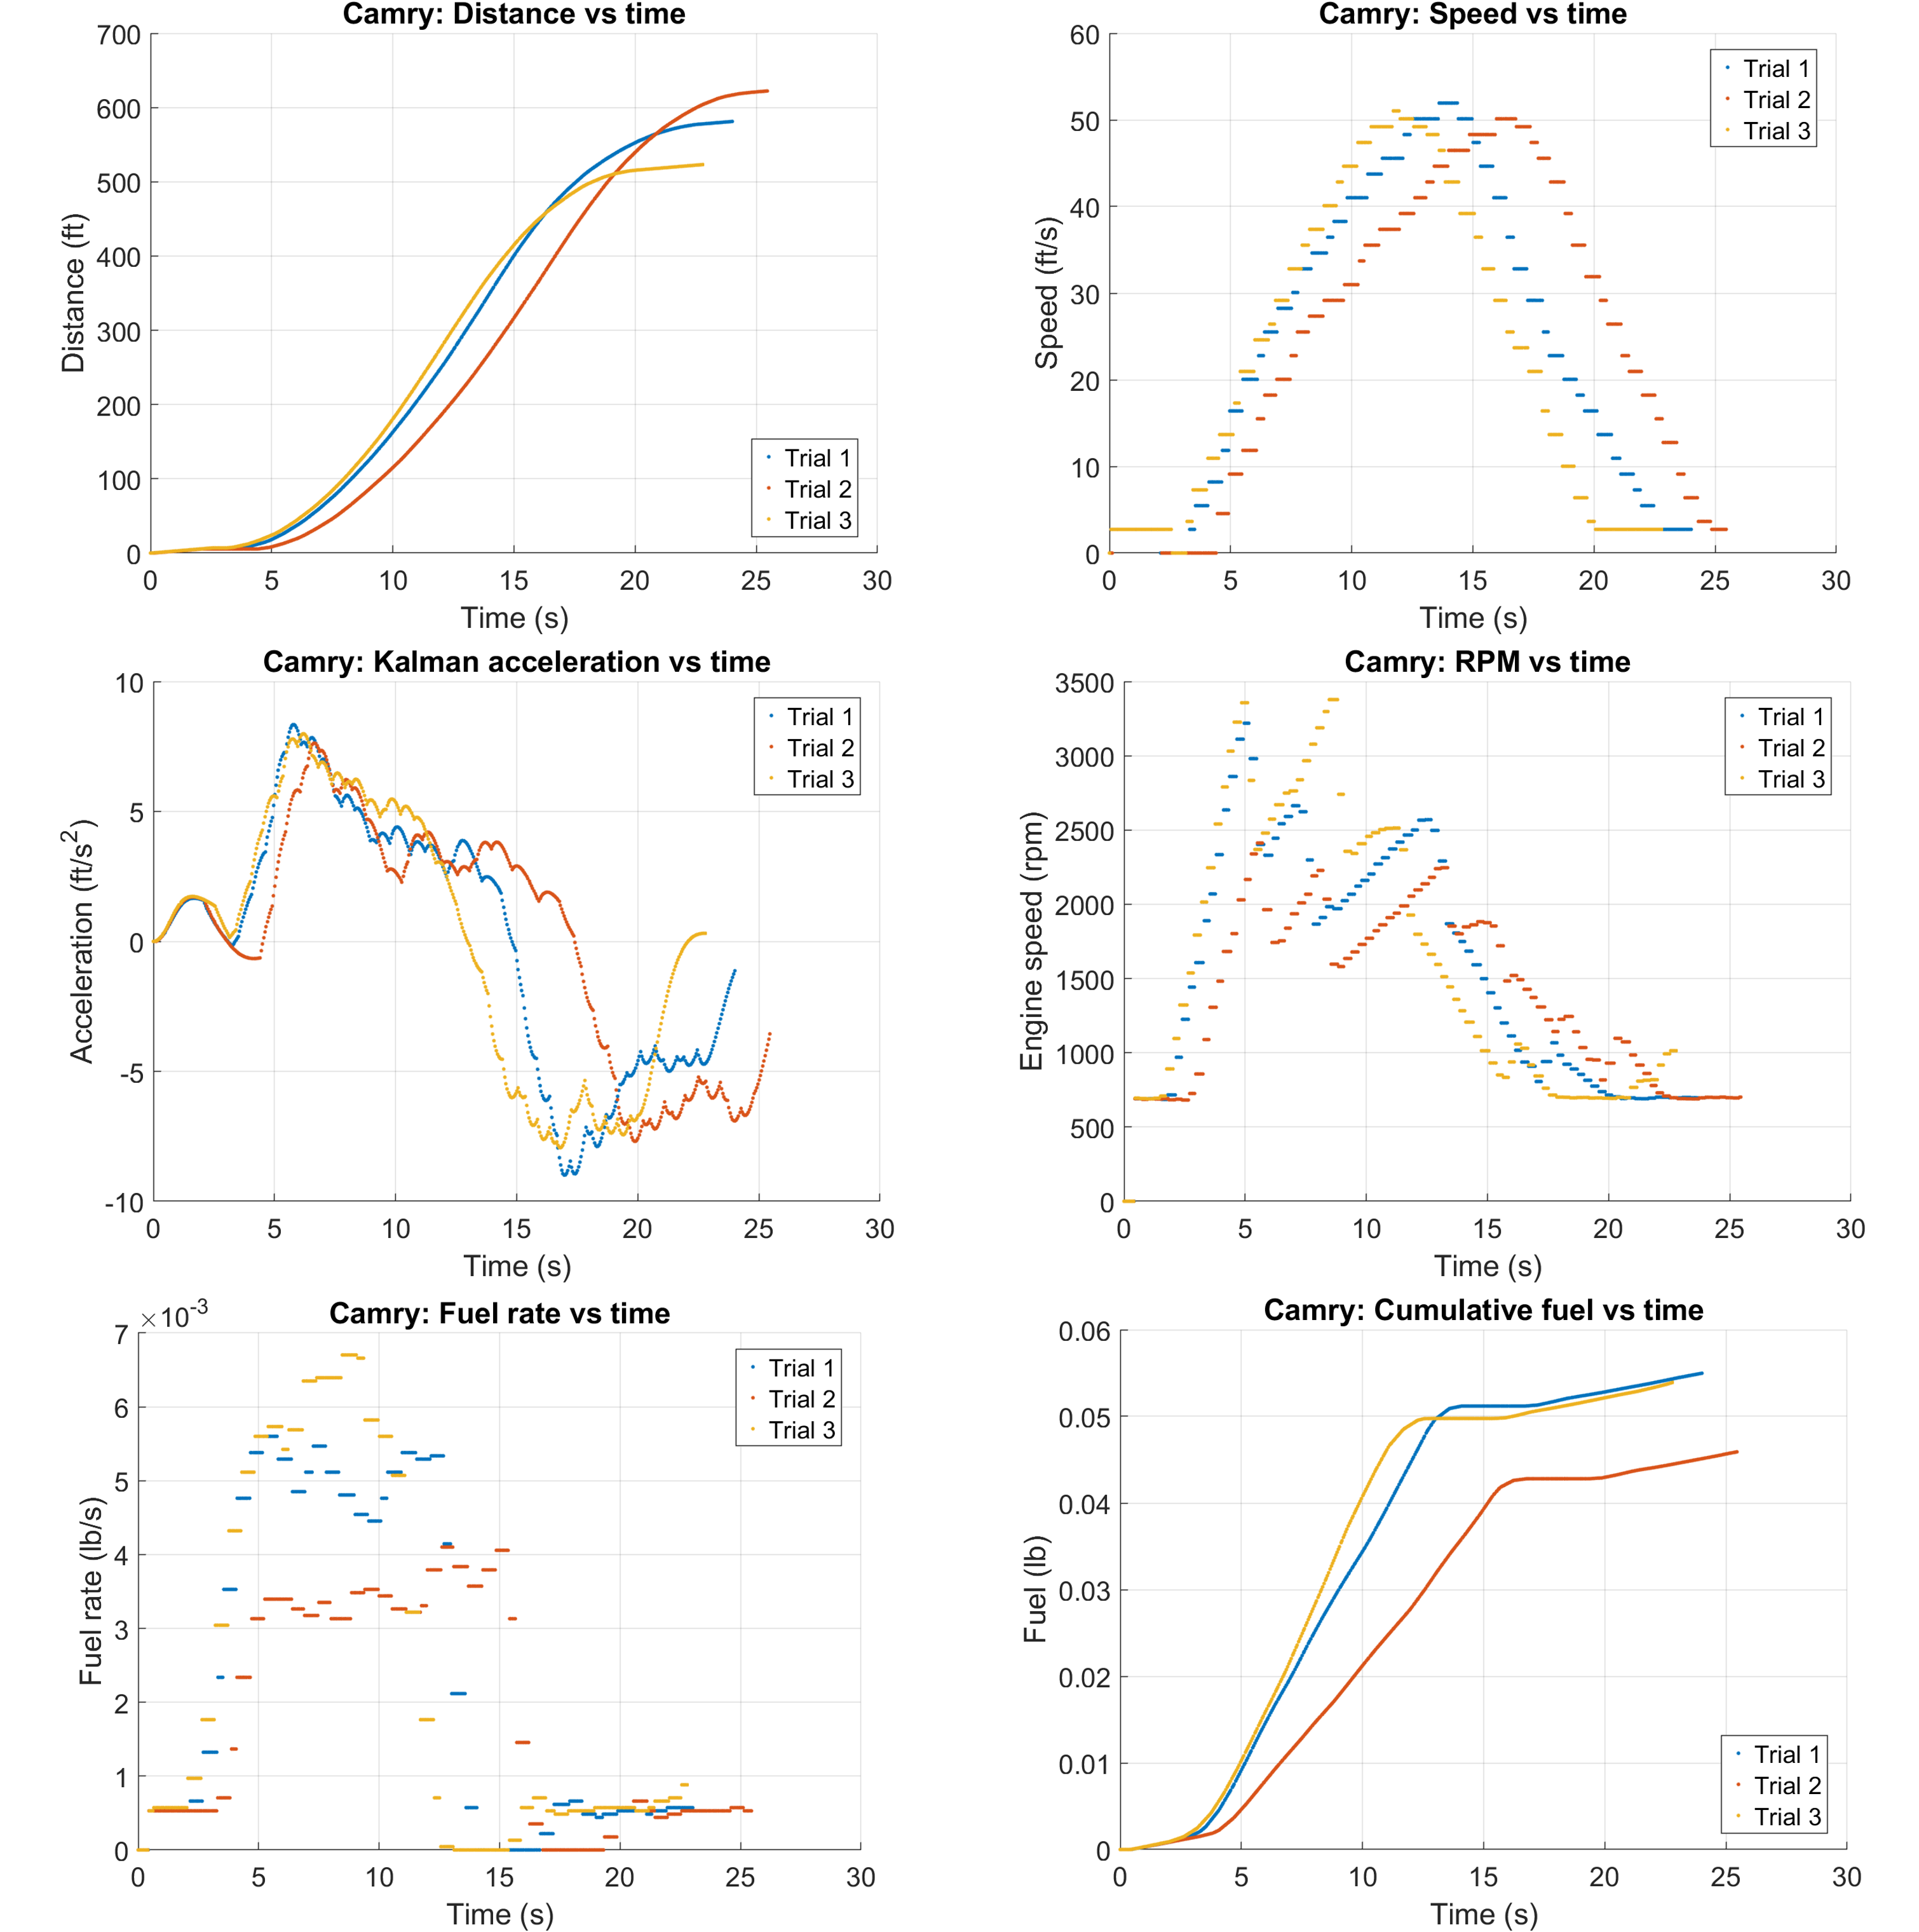
Fig. 2. Complete Camry records. Distance and fuel mass are cumulative trapezoidal integrals; acceleration is the Kalman estimate. The logs do not include a measured final stop. Fuel quantities remain in mass units.

Jetta phase fits
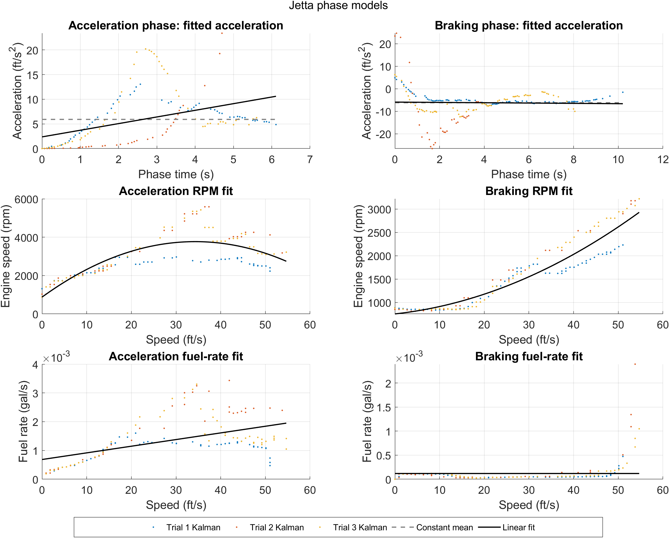
Fig. 3. The acceleration panels compare the mean and linear fits to Kalman estimates, not measured acceleration. RPM and fuel panels use recorded or derived samples with separate phase fits. Dots retain the spread among all three trials; lines show the fitted models.

Camry phase fits
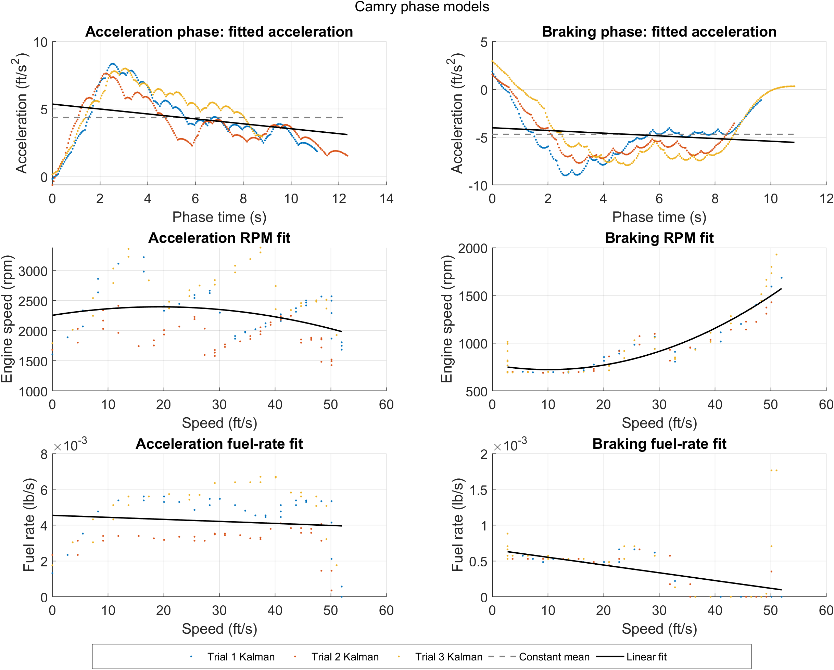
Fig. 4. Mean and linear acceleration models fitted to pooled Kalman estimates, with separate RPM and fuel phase curves. Camry fuel is mass rate in lb/s. The last recorded speeds remain above zero; modeled stops extend beyond those endpoints.

Jetta course predictions
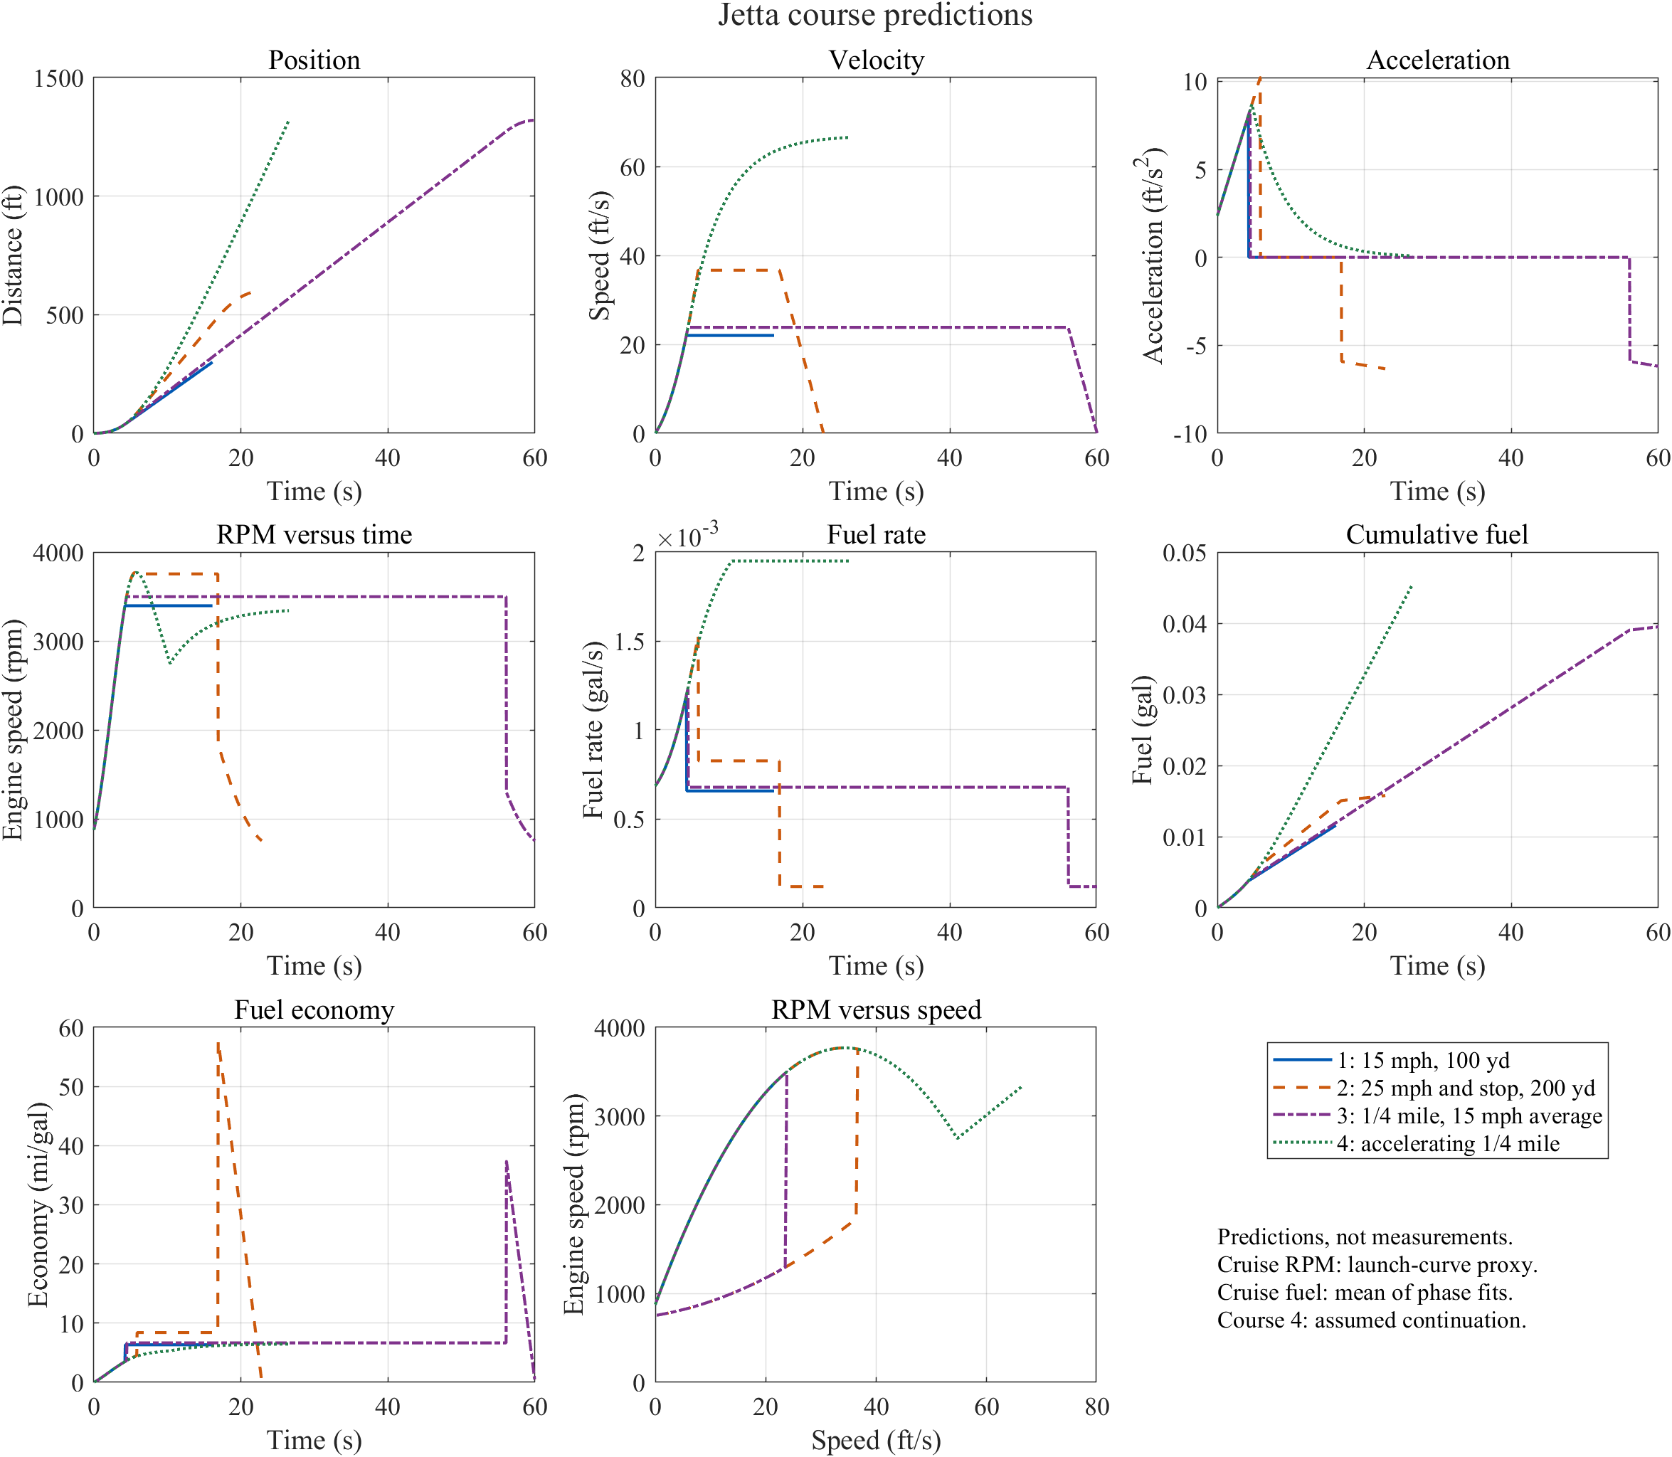
Fig. 5. Four modeled courses using the same fitted phase laws. Curves are scenario predictions, not additional measurements. Course 3 uses a chosen rest-to-rest profile; Course 4 uses the positive-acceleration extension. The cruise fuel estimate is assumption-dependent.

Camry course predictions
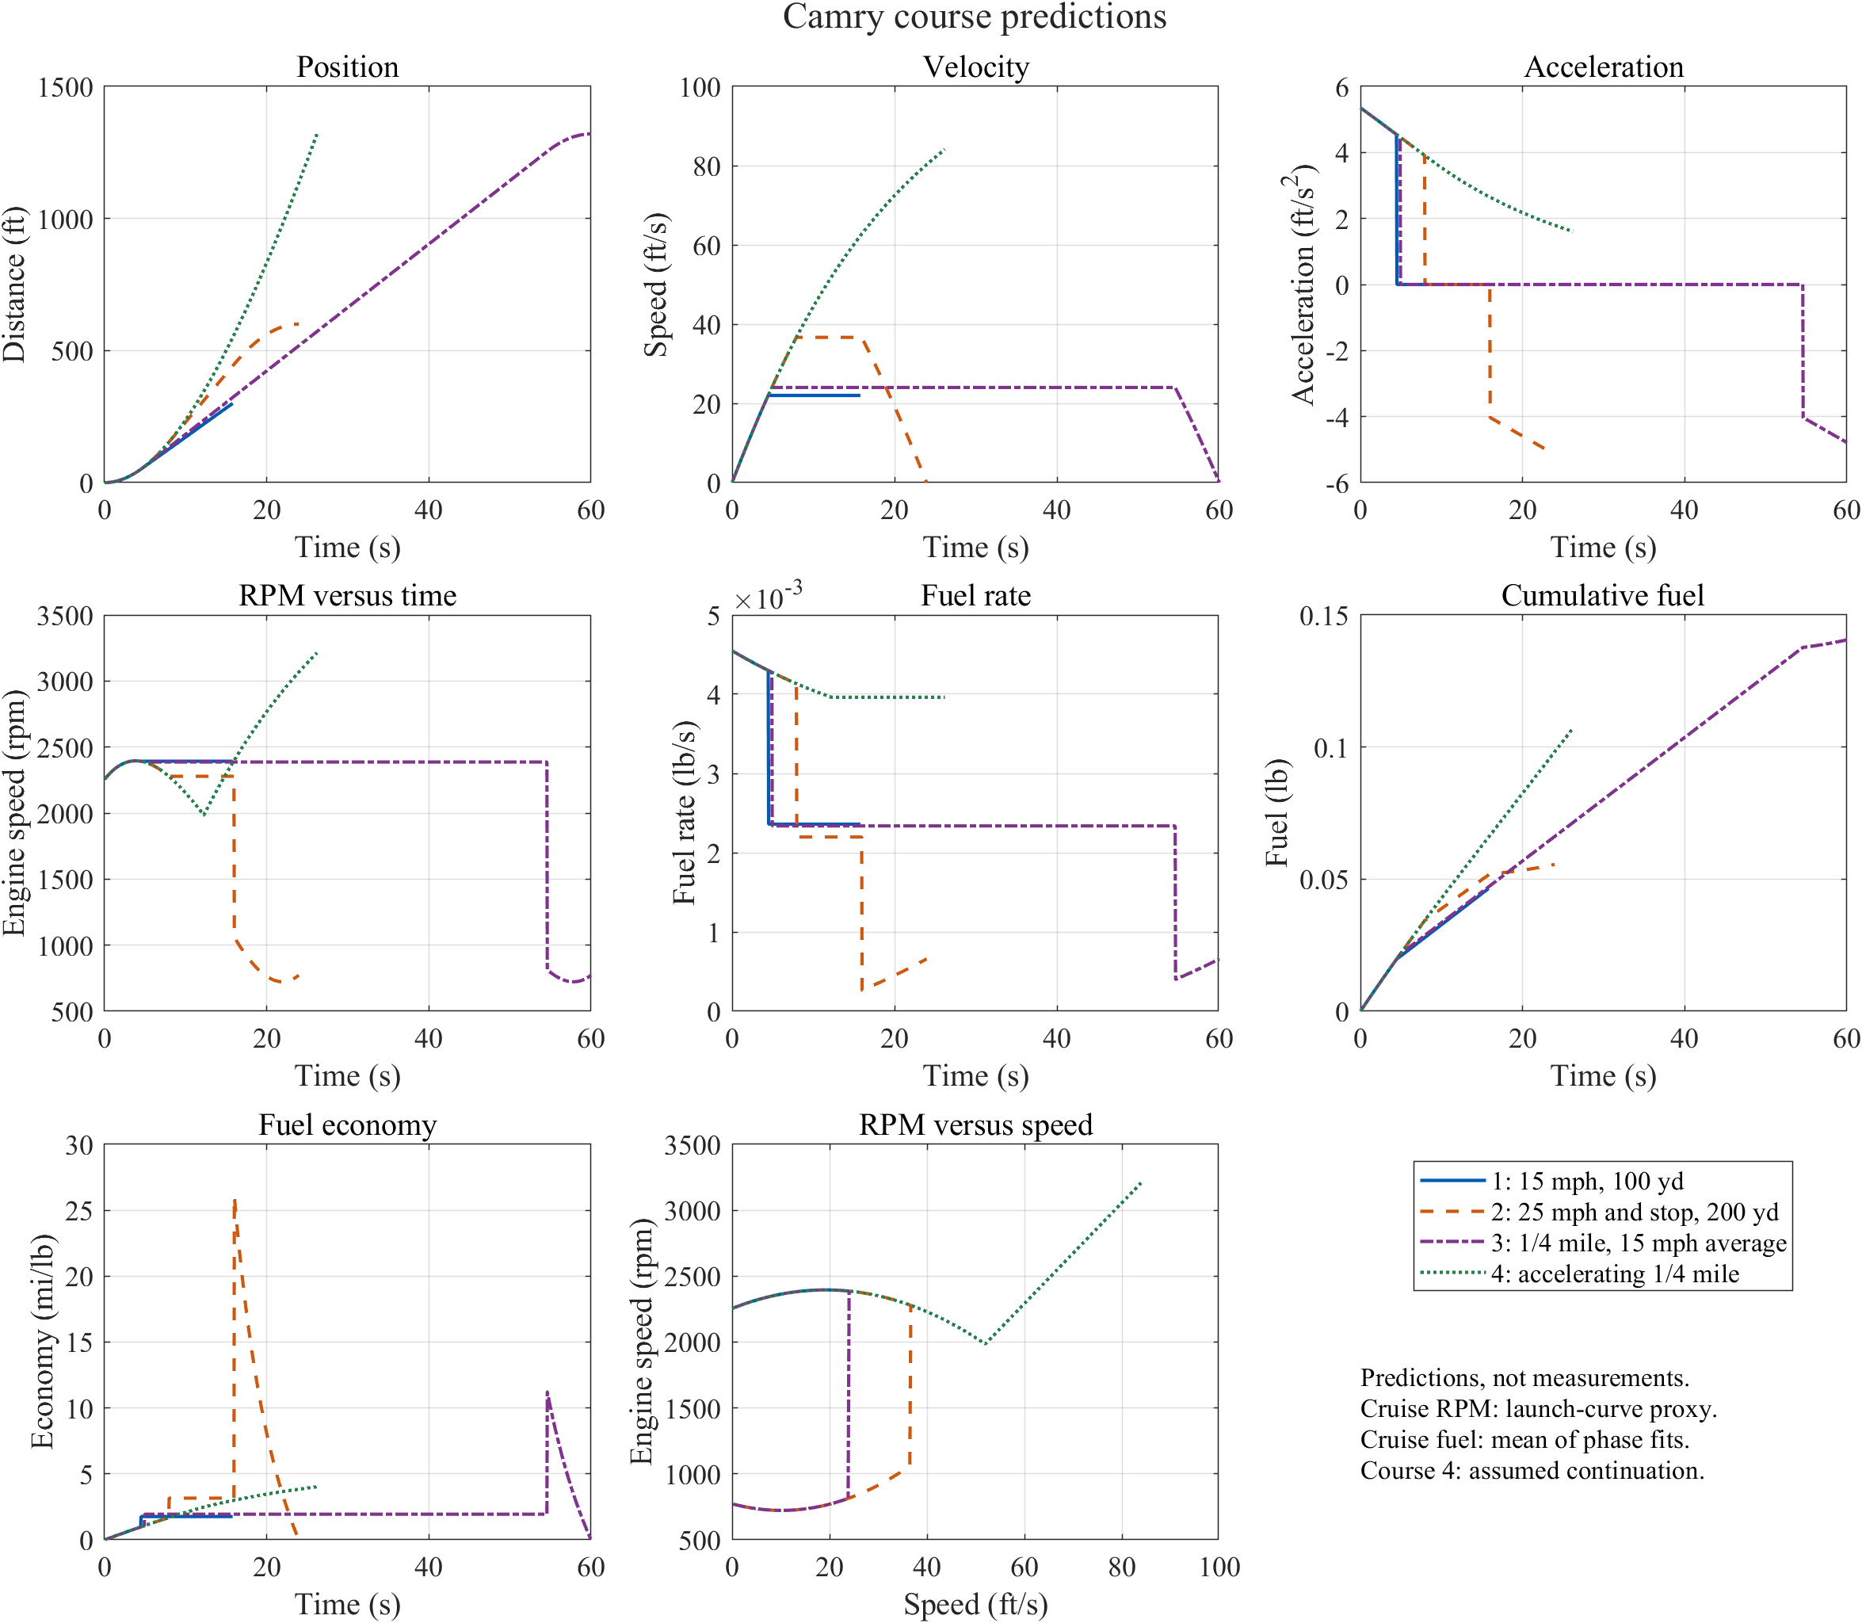
Fig. 6. The same course definitions applied to the Camry fits. Fuel economy is expressed as mi/lb, not MPG. Travel beyond the measured range and the final stop are extrapolations.

